Scribble to Digital

Project Overview
Handling handwritten notes in digital environments is often difficult for students and professionals. Images of notes may contain unclear handwriting, poor lighting conditions, or mixed content such as reminders, tasks, and general notes. These issues make it difficult to convert handwritten content into usable digital text.
The Scribble to Digital system is designed to solve this problem by automatically converting handwritten notes into well-structured digital text. The application improves the clarity of uploaded images, extracts the text using Optical Character Recognition (OCR), and then applies Generative AI techniques to refine the text and identify important tasks.
The system is implemented using Streamlit to build the interactive interface and Python for backend processing.

Use Case Scenarios

Scenario 1: Digitizing Handwritten Notes with Image Enhancement
Users begin by uploading a photograph of their handwritten notes through the Streamlit application. Since images may contain shadows, low brightness, or noisy backgrounds, the system first performs image enhancement.
Using OpenCV, the image is converted to grayscale, brightness and contrast are adjusted, and noise reduction techniques are applied. Thresholding is then used to highlight the handwritten text.
Once the image quality improves, the processed image is forwarded to the OCR module to extract text more accurately.
The output produced in this stage includes:
- Enhanced image for improved visibility
- Raw text extracted from handwriting
- Preprocessed data ready for AI analysis

Scenario 2: AI-Based Text Refinement and Reconstruction
The text extracted from OCR is often imperfect because handwriting styles differ from person to person. As a result, OCR output may contain spelling mistakes, incomplete words, or poorly structured sentences.
To address this, the system uses Generative AI (Gemini 2.5 Flash) to analyze the extracted text and improve its quality. The AI performs several corrections such as:
- Fixing spelling errors
- Improving grammar and sentence flow
- Interpreting incomplete or partially recognized words
- Organizing content into readable paragraphs
This step transforms raw OCR output into a clean and professional digital note.

Scenario 3: Automatic Task Detection and To-Do List Generation
Many handwritten notes contain both general information and actionable items. Manually identifying tasks from notes can take additional time.
The AI module analyzes the processed text and identifies sentences that represent actions or reminders. These items are then converted into a structured to-do list.
The results include:
- Clean formatted notes
- Clearly separated task list
This feature helps users quickly focus on tasks without scanning through the entire note.

System Architecture
Scribble to Digital is designed as an AI-enabled web application that transforms handwritten notes into digital text. The system architecture integrates multiple technologies to perform image processing, text extraction, and AI-based correction.
The key technologies used in the system include:
- Streamlit – provides the web interface and handles user interaction
- OpenCV – performs image preprocessing and enhancement
- EasyOCR / Tesseract – extracts text from images
- Google Gemini 2.5 Flash – processes OCR text and performs contextual correction
- Python – serves as the primary programming language for system development
The system workflow follows these steps:
- User uploads handwritten image
- Image preprocessing improves clarity
- OCR extracts text from the image
- AI processes the extracted text
- Clean notes and tasks are generated

Core Technologies Used
Streamlit
Used to create the web interface for uploading images and displaying results.
Google Gemini 2.5 Flash
Provides AI capabilities for correcting grammar, reconstructing sentences, and identifying tasks.
OpenCV
Performs image processing operations such as grayscale conversion and thresholding.
EasyOCR / Tesseract
Responsible for extracting textual information from handwritten images.
Python
Acts as the main development language connecting all modules.

System Components

Streamlit User Interface
The interface allows users to upload handwritten note images and view the processed results. It also displays enhanced images, OCR text, corrected notes, and extracted tasks.

Image Processing Module
This module enhances the uploaded image using OpenCV techniques such as grayscale conversion, brightness adjustment, and noise reduction. These improvements increase OCR accuracy.

OCR Module
The OCR engine reads the processed image and converts the handwriting into raw digital text.

Generative AI Module
The AI module refines the OCR output by correcting errors, improving sentence structure, and identifying actionable tasks.

Export Module
This component enables users to download the processed results in formats such as text files or documents.
Pre-requisites
- Google AI Studio Account Setup – To generate Gemini API Key
- Python 3.8+ Installed
- Streamlit Framework Installed
- 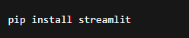
- Required Python Libraries
  - opencv-python
  - pytesseract / easyocr
  - google-generativeai
  - pillow
  - reportlab (for PDF export)
  - python-docx (for Word export)
- Tesseract OCR Installed (if using pytesseract)

Project Workflow
The working process of the Scribble to Digital application follows several stages:

Step 1 – AI Configuration
The system connects to the Gemini API using an API key generated from Google AI Studio.

Step 2 – Image Upload
Users upload handwritten note images through the Streamlit interface.

Step 3 – Image Enhancement
OpenCV processes the image to improve brightness, contrast, and clarity.

Step 4 – OCR Extraction
EasyOCR extracts the handwritten text from the processed image.

Step 5 – AI Text Processing
Gemini analyzes the extracted text and produces a refined version of the notes.

Step 6 – Task Identification
The AI detects action-oriented statements and converts them into a to-do list.

Step 7 – Result Display
The application shows:
- Raw OCR text
- Corrected digital notes
- Extracted tasks.
These steps are explained clearly in the below activity.
1. Gemini AI Setup & Initialization
Activity 1.1: Set up Google AI Studio with Gemini API
- Create or sign in to Google AI Studio account
- Generate API key for Gemini model access
- Enable Gemini 2.5 Flash model
- Test API integration using a sample prompt

Activity 1.2: Configure API Keys and Environment
- Store GEMINI_API_KEY securely in .env file
- Load environment variables using python-dotenv
- Configure model parameters:
  - Temperature
  - Max output tokens
  - Response format
- Validate API connectivity inside Streamlit app

Activity 1.3: Design AI Prompts for Note Processing
- Create prompt template for:
  - Grammar correction
  - Sentence reconstruction
  - Formatting messy text into structured paragraphs
- Design separate prompt for:
  - To-do task extraction
  - Task prioritization (if needed)
- Test prompt effectiveness with sample handwritten text

2. Core Functionality Development

Activity 2.1: Design Streamlit App Structure
- Create modular project structure:
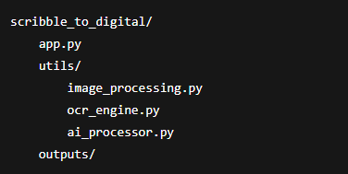
Configure Streamlit layout:
- Title & description
- File uploader
- Processing buttons
- Output display sections
Activity 2.2: Implement Image Processing Module
- Accept image upload (JPG/PNG)
- Apply preprocessing using OpenCV:
  - Convert to grayscale
  - Adjust brightness & contrast
  - Remove noise
  - Apply thresholding
- Display enhanced image preview in Streamlit

Activity 2.3: Implement OCR Extraction
- Integrate Tesseract or EasyOCR
- Extract raw handwritten text
- Clean unnecessary symbols
- Display raw OCR output for comparison

Activity 2.4: AI-Based Contextual Processing
- Send OCR text to Gemini API
- Perform:
  - Grammar correction
  - Sentence completion
  - Context-based word guessing
  - Formatting into structured notes
- Extract action items separately
- Return:
  - Clean digital text
  - Structured to-do list

3. Streamlit UI Implementation

Activity 3.1: Build Interactive UI Components
- st.file_uploader() for image upload
- st.image() for displaying uploaded & enhanced image
- st.button() for processing steps
- st.spinner() for loading indication
- st.text_area() for displaying extracted text

Activity 3.2: Display Structured Results
- Section 1: Enhanced Image
- Section 2: Raw OCR Text
- Section 3: AI-Corrected Digital Notes
- Section 4: Extracted To-Do Tasks (bullet format)
Optional:
- Checkbox to show/hide raw OCR
- Download buttons for final output

Activity 3.3: Add Export Functionality
- Generate downloadable:
  - PDF (using ReportLab)
  - Word file (using python-docx)
- Use st.download_button()
- Allow preview before download

4. Testing & Optimization

Activity 4.1: Functional Testing
- Test with:
  - Clear handwriting
  - Messy handwriting
  - Mixed text + tasks
  - Bullet points
- Validate OCR accuracy
- Validate AI corrections

Activity 4.2: Evaluate AI Response Quality
- Check:
  - Grammar correction accuracy
  - Logical sentence flow
  - Proper formatting
  - Correct task extraction
- Ensure no hallucinated content

Activity 4.3: Performance Optimization
- Optimize image preprocessing steps
- Reduce API token usage
- Add error handling for:
  - Empty image
  - API failure
  - OCR failure
- Improve prompt clarity

Activity 4.4: Ensure Export Quality
- Validate PDF formatting
- Check Word document structure
- Ensure file compatibility
- Test downloads across browsers

Testing and Optimization
To ensure the reliability of the system, several test cases were evaluated using different handwriting styles and image conditions.

Clear Handwriting
High-quality images produced highly accurate OCR results and clean AI-generated notes.

Moderate Handwriting Quality
OCR extracted readable text, and the AI successfully corrected most errors.

Low-Quality Images
Although OCR results were limited, the AI was able to generate partially meaningful text after contextual correction.

Notes Without Tasks
When notes contained only informational content, the system correctly returned cleaned text without generating unnecessary tasks.

Project Milestones

Milestone 1: Generative AI Setup and Initialization
The first stage of the project focuses on setting up the Generative AI environment required for processing handwritten notes. The system integrates Google Gemini 2.5 Flash to enhance OCR text and extract useful information.
The main objectives of this phase include:
- Establishing access to the Gemini API
- Configuring environment variables
- Testing AI responses using sample prompts

Activity 1.1: Google AI Studio Configuration
To enable AI functionality, a Google AI Studio account must be created. After logging in, an API key is generated which allows the application to communicate with the Gemini model.
Steps involved:
- Visit the Google AI Studio website.
- Log in using a Google account.
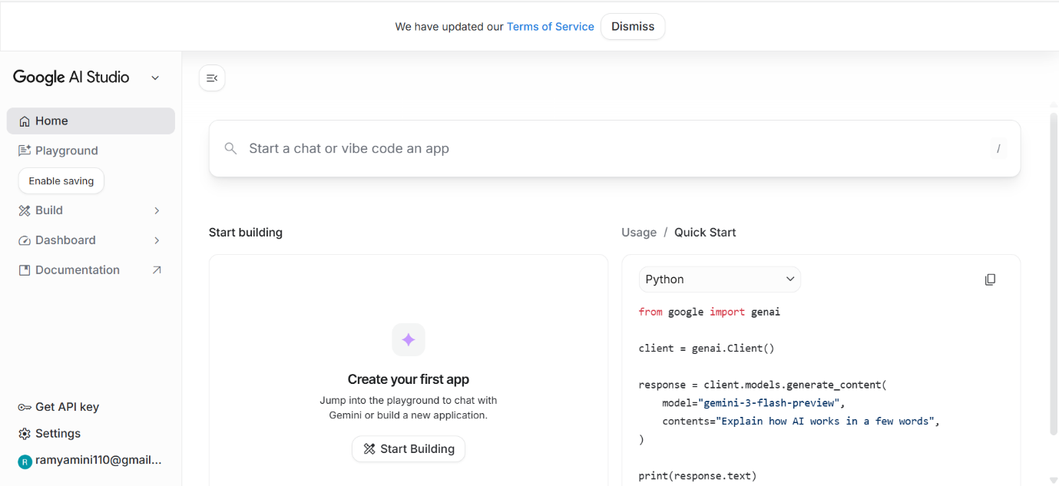
- Generate a new API key.
- Store the key securely for use in the application.
The Gemini 2.5 Flash model is selected because it provides fast response time and efficient token usage, making it suitable for text correction and task extraction.

Activity 1.2: Environment Configuration

Add the API Key.

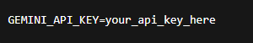
The API key must be stored securely inside an environment file (.env). The project uses the python-dotenv library to load these environment variables during runtime.
Necessary libraries installed in this stage include:
- streamlit
- google-generativeai
- python-dotenv
- opencv-python
- easyocr or pytesseract
- pillow
After installation, a small test program is executed to verify whether the application can successfully communicate with the Gemini API.

Activity 1.3: Prompt Design for AI Processing
To obtain meaningful results from the AI model, structured prompts are created. These prompts instruct the model to perform specific tasks such as:
- Correcting spelling errors
- Improving sentence structure
- Reconstructing incomplete words
- Formatting messy notes into readable text
A separate prompt template is also created to extract to-do tasks from the text.
The prompts are tested using sample handwritten text to ensure that the AI produces accurate and meaningful results.

Milestone 2: Core Application Development
This stage focuses on implementing the core features of the application using Python and Streamlit.
The primary goal is to develop the system that can:
- Accept handwritten images
- Process images for better clarity
- Extract text using OCR
- Improve text using Generative AI
- Display structured output to users

File Explorer Structure
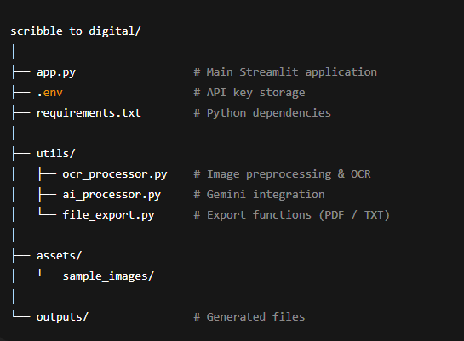

Activity 2.1: Streamlit Application Structure
Import the required library.
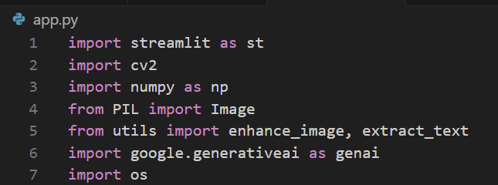
The project is organized into multiple modules to keep the code clean and manageable.
The Streamlit interface includes:
- Application title and description
- Image upload section
- Buttons to start processing
- Sections to display results
This structure ensures that users can easily interact with the system.

Activity 2.2: Image Processing Implementation
In this stage, image preprocessing techniques are implemented using OpenCV.
Key preprocessing steps include:
- Converting images to grayscale
- Adjusting brightness and contrast
- Reducing noise from the image
- Applying thresholding to highlight text
These techniques improve the clarity of the image and increase the accuracy of OCR text extraction.
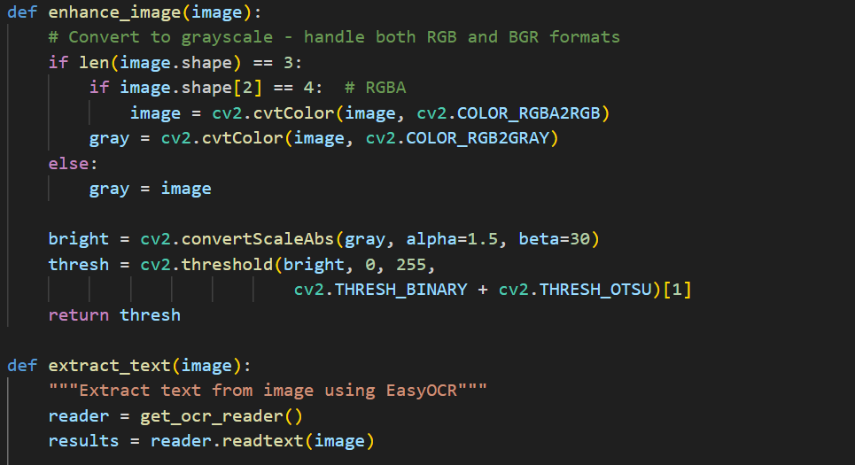

Activity 2.3: OCR Integration
The system integrates an OCR engine such as EasyOCR or Tesseract to extract handwritten text from images.
The OCR module performs the following tasks:
- Detect text regions in the image
- Convert handwriting into machine-readable text
- Remove unwanted symbols or noise from extracted text
The extracted text is displayed in the interface for comparison with the corrected output.

Activity 2.4: AI-Based Text Processing
Once OCR text is generated, it is sent to the Gemini AI model for processing.
The AI performs several improvements such as:
- Correcting grammar and spelling mistakes
- Reconstructing incomplete words
- Improving sentence clarity
- Organizing the content into structured paragraphs
The system also identifies task-related statements and converts them into a to-do list.
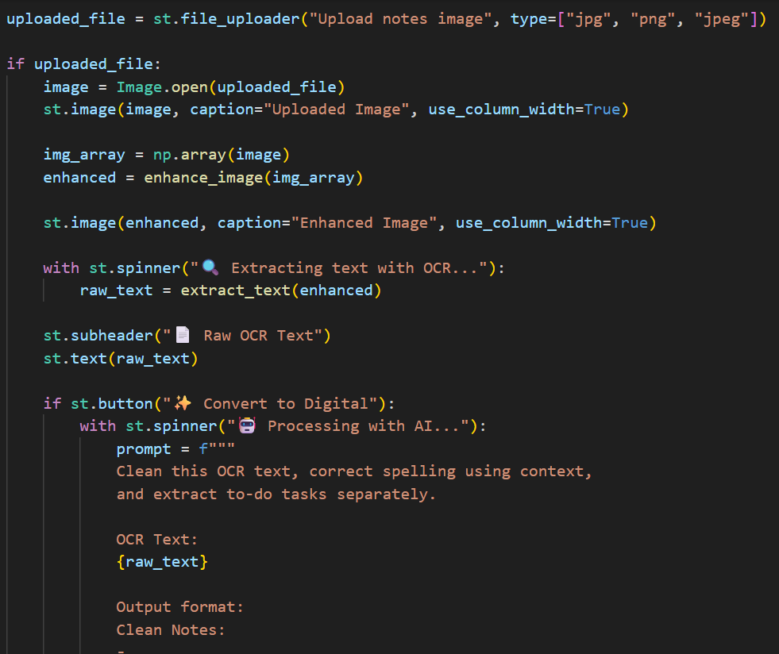

Milestone 3: Backend Development
This milestone focuses on implementing the backend logic responsible for handling data processing, AI integration, and application workflows.
The backend is responsible for:
- Managing image uploads
- Running OCR processing
- Sending requests to the AI model
- Generating structured outputs

Activity 3.1: Input Validation and Error Handling
To ensure reliable operation, the system validates user input before processing.
The application checks:
- Supported file formats (JPG, PNG, JPEG)
- Empty or invalid file uploads
- File size limitations
Proper error handling is implemented to prevent application crashes.
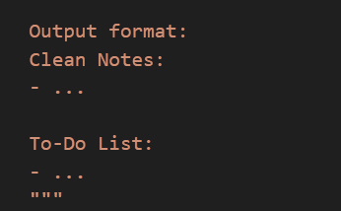

Activity 3.2: Modular Code Design
The backend follows a modular design where different responsibilities are separated into different files.
Examples include:
- OCR module for text extraction
- AI module for text correction and task identification
- Export module for generating downloadable files
This structure improves maintainability and scalability of the project.
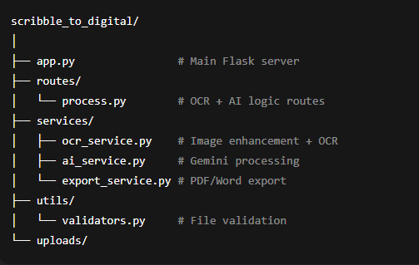
Main Application Structure

Activity 3.3: Export Functionality
The application provides options for downloading the processed output.
Supported export formats include:
- Text files containing cleaned notes
- CSV files containing extracted tasks
- Optional PDF or Word document formats
This allows users to save and reuse the processed information easily.

Milestone 4: User Interface Development
This phase focuses on building a simple and user-friendly interface using Streamlit.
The UI enables users to easily upload images, process notes, and view results.

Activity 4.1: Landing Page Design
The landing page introduces the application and highlights its main features.
The page includes:
- Project title and description
- Overview of system features
- Instructions for users
Feature sections highlight the capabilities of the system, such as note upload, smart correction, and task extraction.
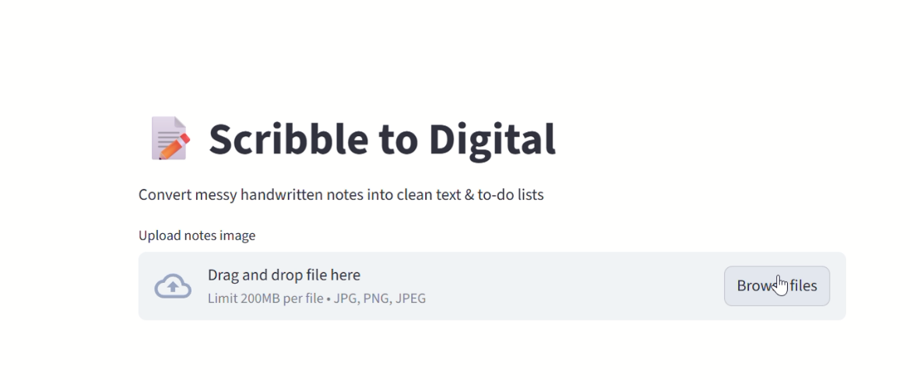

Activity 4.2: Processing Interface
The main processing page allows users to upload handwritten note images and start the conversion process.
Main components include:
- Image upload field
- Convert button
- Reset button
UI Layout (Streamlit Flow)
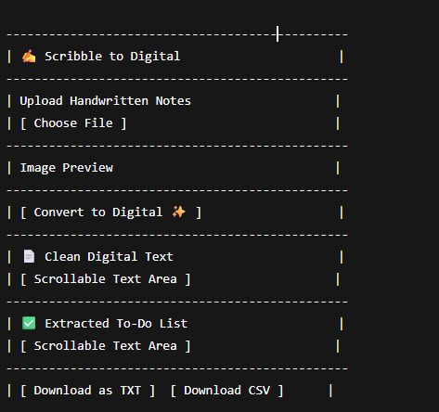

After processing, the application displays the enhanced image, raw OCR text, corrected notes, and extracted tasks.

Activity 4.3: Result Visualization
The output is displayed in organized sections to improve readability:
- Enhanced Image
- Extracted OCR Text
- AI-Generated Clean Notes
- To-Do Task List
Optional download buttons allow users to save the results.
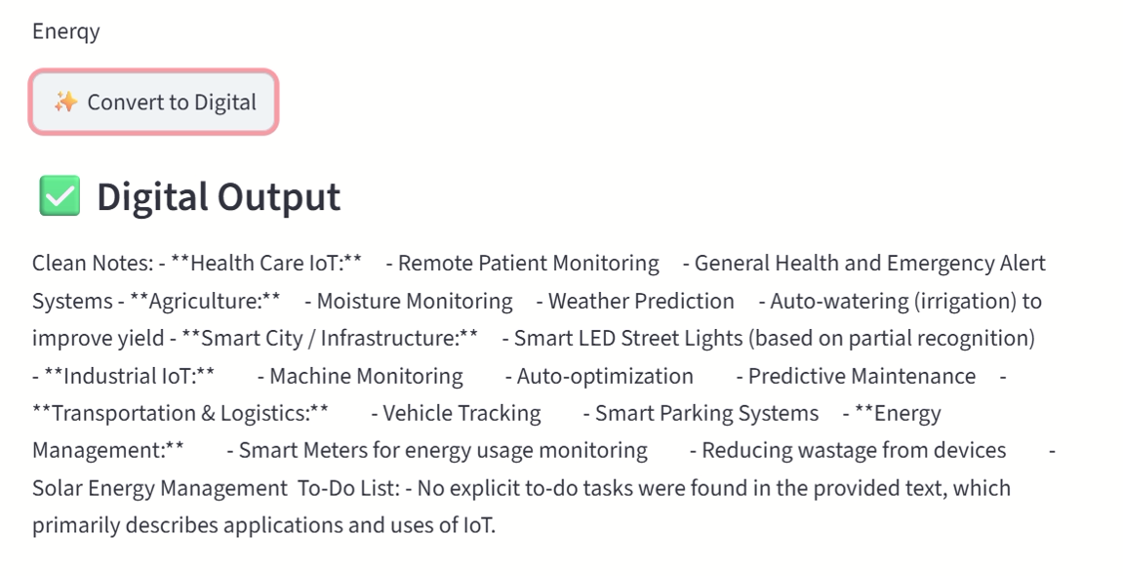

Milestone 5: Testing and Performance Improvement
The final stage of the project focuses on verifying system performance and improving reliability.
Several test cases are used to evaluate the system under different conditions.

Activity 5.1: Functional Testing
The system is tested with different types of handwritten notes, including:
- Clear handwriting images
- Messy handwriting samples
- Notes containing tasks and reminders
- Bullet-point style notes
These tests ensure that the application performs correctly in various scenarios.

Activity 5.2: Quality Evaluation
The following aspects are evaluated:
- OCR text recognition accuracy
- Effectiveness of AI grammar correction
- Accuracy of task identification
- Consistency of output formatting
This evaluation helps determine whether the system produces useful and reliable results.

Activity 5.3: Performance Optimization
Several improvements are made to enhance performance, including:
- Optimizing image preprocessing operations
- Reducing unnecessary AI token usage
- Adding loading indicators for better user experience
- Implementing error handling for OCR and API failures
These optimizations ensure that the application runs smoothly even when processing multiple images.

Conclusion
The Scribble to Digital system demonstrates how modern AI technologies can bridge the gap between handwritten notes and digital documentation. By combining image preprocessing, OCR technology, and generative AI, the system converts handwritten content into organized digital information.
The application not only digitizes handwritten text but also enhances it by improving readability and automatically extracting tasks. This reduces manual effort and increases productivity for users who frequently work with handwritten notes.
With its modular architecture and user-friendly interface, the system provides a practical solution for students, researchers, and professionals who want to convert handwritten ideas into structured digital content.

